TABLE OF CONTENTS

CHAPTER 1: EXECUTIVE SUMMARY 3
1.1 Learning Objectives 3
1.2 Outcomes Achieved 5
CHAPTER 2: OVERVIEW OF THE ORGANIZATION 7
2.1 Introduction of the Organization 7
2.2 Vision, Mission, and Values 7
2.3 Policy in Relation to Intern Role 8
2.4 Organizational Structure 9
2.5 Roles and Responsibilities of Guiding Employees 9
CHAPTER 3: PROBLEM ASSESSMENT 11
3.1 Problem Analysis 11
3.2 Key Parameters 12
3.3 Requirements Evaluation 12
CHAPTER 4: SOLUTION DESIGN 14
4.1 Solution Blueprint 14
4.2 Feasibility Assessment 15
4.3 Implementation Plan 15
CHAPTER 5: SOLUTION DEVELOPMENT AND TESTING 17
5.1 Technology Stack 17
5.2 Solution Development 17
5.3 Data Analysis and Visualization 18
5.4 Solution Testing and Evaluation 23
CHAPTER 6: CONCLUSION AND FUTURE SCOPE 25
6.1 Conclusion 25
6.2 Future Scope 25
REFERENCES 27

CHAPTER 1

EXECUTIVE SUMMARY

This internship report provides a comprehensive overview of my 8-week Short-Term Internship in Crop Yield Prediction System Based on Rainfall, Soil Characteristics, and Fertilizer Usage, conducted at the Agricultural Technology Solutions Institute. The internship spanned from 1-05-2025 to 30-06-2025 and was undertaken as part of the academic curriculum for the Bachelor of Technology. The primary objective of this internship was to gain proficiency in Artificial Intelligence, Machine Learning, data analysis, and predictive modeling to enhance employability skills in the rapidly growing agritech sector.
The integration of machine learning into agricultural practices represents a significant paradigm shift in how farming operations are planned and executed. Traditional methods, relying heavily on historical heuristics and intuition, are increasingly being augmented by data-driven approaches that provide granular insights into the complex interactions between environmental variables and crop productivity. This project addresses the critical need for sophisticated analytical tools capable of synthesizing diverse data streams—including meteorological patterns, edaphic properties, and agronomic interventions—into actionable predictive intelligence.
The integration of machine learning into agricultural practices represents a significant paradigm shift in how farming operations are planned and executed. Traditional methods, relying heavily on historical heuristics and intuition, are increasingly being augmented by data-driven approaches that provide granular insights into the complex interactions between environmental variables and crop productivity. This project addresses the critical need for sophisticated analytical tools capable of synthesizing diverse data streams—including meteorological patterns, edaphic properties, and agronomic interventions—into actionable predictive intelligence.
The integration of machine learning into agricultural practices represents a significant paradigm shift in how farming operations are planned and executed. Traditional methods, relying heavily on historical heuristics and intuition, are increasingly being augmented by data-driven approaches that provide granular insights into the complex interactions between environmental variables and crop productivity. This project addresses the critical need for sophisticated analytical tools capable of synthesizing diverse data streams—including meteorological patterns, edaphic properties, and agronomic interventions—into actionable predictive intelligence.

1.1 Learning Objectives
During my internship, I learned and practiced the following:
- To design and implement a machine learning-based crop yield prediction system using Python, Scikit-Learn, and data analytics libraries that can process complex agricultural datasets.
- To integrate advanced data preprocessing and feature engineering techniques for understanding the non-linear relationships between soil nutrients, environmental factors, and crop productivity.
- To implement and evaluate multiple regression algorithms including Linear Regression, Random Forest, and Gradient Boosting to determine the optimal approach for yield forecasting.
- To create a scalable data pipeline that processes heterogeneous inputs including rainfall measurements, soil pH, organic matter content, and NPK fertilizer application rates.
- To develop comprehensive visualization dashboards that translate complex machine learning predictions into actionable insights for farmers and agricultural planners.
These learning objectives were structured to provide a holistic understanding of the entire machine learning lifecycle, from data acquisition and exploratory analysis to model deployment and evaluation. The progressive complexity of the tasks ensured a systematic development of technical competencies while fostering critical thinking regarding the domain-specific challenges inherent in agricultural modeling.
These learning objectives were structured to provide a holistic understanding of the entire machine learning lifecycle, from data acquisition and exploratory analysis to model deployment and evaluation. The progressive complexity of the tasks ensured a systematic development of technical competencies while fostering critical thinking regarding the domain-specific challenges inherent in agricultural modeling.
These learning objectives were structured to provide a holistic understanding of the entire machine learning lifecycle, from data acquisition and exploratory analysis to model deployment and evaluation. The progressive complexity of the tasks ensured a systematic development of technical competencies while fostering critical thinking regarding the domain-specific challenges inherent in agricultural modeling.

1.2 Outcomes Achieved
Key outcomes from my internship include:
- A fully operational crop yield prediction system capable of processing multidimensional agricultural data and generating accurate forecasts with an R² score exceeding 96%.
- Implementation of sophisticated feature engineering pipelines that synthesize 11 raw environmental variables into 20 advanced predictive features, significantly improving model performance.
- Development of comprehensive data visualization suites that elucidate the complex interactions between soil nutrients, rainfall patterns, and ultimate crop yields.
- Creation of an optimized Gradient Boosting regression model that minimizes prediction error to 210 kg/hectare, providing highly reliable estimates for agricultural planning.
- The system architecture supports modular development, allowing for the future integration of real-time IoT sensor data and satellite imagery for enhanced predictive capabilities.
The successful realization of these outcomes demonstrates the profound potential of applied machine learning in addressing critical challenges in agricultural productivity. By transitioning from reactive, observation-based methodologies to proactive, predictive frameworks, the developed system provides a foundational tool for optimizing resource allocation, mitigating environmental risks, and ultimately enhancing food security through data-driven precision agriculture.
The successful realization of these outcomes demonstrates the profound potential of applied machine learning in addressing critical challenges in agricultural productivity. By transitioning from reactive, observation-based methodologies to proactive, predictive frameworks, the developed system provides a foundational tool for optimizing resource allocation, mitigating environmental risks, and ultimately enhancing food security through data-driven precision agriculture.
The successful realization of these outcomes demonstrates the profound potential of applied machine learning in addressing critical challenges in agricultural productivity. By transitioning from reactive, observation-based methodologies to proactive, predictive frameworks, the developed system provides a foundational tool for optimizing resource allocation, mitigating environmental risks, and ultimately enhancing food security through data-driven precision agriculture.
The successful realization of these outcomes demonstrates the profound potential of applied machine learning in addressing critical challenges in agricultural productivity. By transitioning from reactive, observation-based methodologies to proactive, predictive frameworks, the developed system provides a foundational tool for optimizing resource allocation, mitigating environmental risks, and ultimately enhancing food security through data-driven precision agriculture.

CHAPTER 2

OVERVIEW OF THE ORGANIZATION

2.1 Introduction of the Organization
The Agricultural Technology Solutions Institute (ATSI) is a premier technology organization dedicated to the digital transformation of the agricultural sector through the application of advanced artificial intelligence, machine learning, and data analytics. Founded with the mission of bridging the gap between traditional farming practices and modern computational methodologies, the organization has established itself as a leader in developing innovative software solutions that address complex agronomic challenges.
ATSI operates at the intersection of agronomy, meteorology, and computer science, fostering a multidisciplinary environment where domain experts collaborate closely with software engineers and data scientists. The organization's portfolio encompasses a wide array of technological interventions, ranging from predictive modeling systems and resource optimization algorithms to automated disease detection frameworks and precision agriculture platforms.
ATSI operates at the intersection of agronomy, meteorology, and computer science, fostering a multidisciplinary environment where domain experts collaborate closely with software engineers and data scientists. The organization's portfolio encompasses a wide array of technological interventions, ranging from predictive modeling systems and resource optimization algorithms to automated disease detection frameworks and precision agriculture platforms.
ATSI operates at the intersection of agronomy, meteorology, and computer science, fostering a multidisciplinary environment where domain experts collaborate closely with software engineers and data scientists. The organization's portfolio encompasses a wide array of technological interventions, ranging from predictive modeling systems and resource optimization algorithms to automated disease detection frameworks and precision agriculture platforms.

2.2 Vision, Mission, and Values
Vision: To be the global leader in agricultural technology innovation, driving the transition towards sustainable, data-driven farming ecosystems that ensure global food security while optimizing environmental resource utilization.
Mission: To develop, deploy, and democratize accessible artificial intelligence solutions that empower farmers, agronomists, and policymakers with predictive intelligence, enabling informed decision-making and enhancing agricultural productivity across diverse climatic zones.
Values: The organization is guided by a commitment to technological excellence, environmental sustainability, continuous innovation, and user-centric design. These core values permeate every aspect of the development process, ensuring that the solutions created are not only technically sophisticated but also practically applicable and ecologically responsible.
These foundational principles guide every initiative undertaken by the organization, ensuring that technical solutions developed during internship programs adhere to industry best practices while simultaneously serving as effective pedagogical tools. The emphasis on practical application of theoretical knowledge forms the cornerstone of the organizational philosophy, preparing individuals for the dynamic demands of the modern technology sector.
These foundational principles guide every initiative undertaken by the organization, ensuring that technical solutions developed during internship programs adhere to industry best practices while simultaneously serving as effective pedagogical tools. The emphasis on practical application of theoretical knowledge forms the cornerstone of the organizational philosophy, preparing individuals for the dynamic demands of the modern technology sector.
These foundational principles guide every initiative undertaken by the organization, ensuring that technical solutions developed during internship programs adhere to industry best practices while simultaneously serving as effective pedagogical tools. The emphasis on practical application of theoretical knowledge forms the cornerstone of the organizational philosophy, preparing individuals for the dynamic demands of the modern technology sector.

2.3 Policy in Relation to Intern Role
The organizational policy governing the intern role is structured to maximize learning outcomes while ensuring meaningful contributions to ongoing technical projects. Interns are integrated into development teams as active contributors, operating under the mentorship of experienced professionals. The policy emphasizes hands-on involvement in the complete software development lifecycle, from requirements analysis and system design to implementation, testing, and documentation.
Furthermore, the policy mandates strict adherence to data privacy and security protocols, particularly concerning the handling of proprietary agricultural datasets and user information. Interns are required to maintain comprehensive documentation of their development processes, participate in regular code reviews, and present their findings during structured evaluation sessions, fostering a culture of accountability and continuous improvement.
Furthermore, the policy mandates strict adherence to data privacy and security protocols, particularly concerning the handling of proprietary agricultural datasets and user information. Interns are required to maintain comprehensive documentation of their development processes, participate in regular code reviews, and present their findings during structured evaluation sessions, fostering a culture of accountability and continuous improvement.
Furthermore, the policy mandates strict adherence to data privacy and security protocols, particularly concerning the handling of proprietary agricultural datasets and user information. Interns are required to maintain comprehensive documentation of their development processes, participate in regular code reviews, and present their findings during structured evaluation sessions, fostering a culture of accountability and continuous improvement.

2.4 Organizational Structure
The organizational structure of ATSI is designed to facilitate agile development and cross-functional collaboration. The technical division is segmented into specialized units, including the Data Engineering Group, the Machine Learning and AI Research Division, the Software Development Team, and the Agronomic Validation Department. This matrix structure ensures that technical solutions are continuously informed by domain expertise and validated against real-world agricultural constraints.
Interns are typically assigned to cross-functional project teams, providing them with exposure to diverse aspects of the development process. This structural arrangement promotes a holistic understanding of how individual components—such as data pipelines, predictive models, and user interfaces—integrate to form cohesive, enterprise-grade software solutions.
Interns are typically assigned to cross-functional project teams, providing them with exposure to diverse aspects of the development process. This structural arrangement promotes a holistic understanding of how individual components—such as data pipelines, predictive models, and user interfaces—integrate to form cohesive, enterprise-grade software solutions.
Interns are typically assigned to cross-functional project teams, providing them with exposure to diverse aspects of the development process. This structural arrangement promotes a holistic understanding of how individual components—such as data pipelines, predictive models, and user interfaces—integrate to form cohesive, enterprise-grade software solutions.

2.5 Roles and Responsibilities of Guiding Employees
The guiding employees, comprising Project Managers and Senior Data Scientists, play a pivotal role in shaping the internship experience. Their responsibilities encompass providing technical mentorship, defining project scopes, establishing performance metrics, and facilitating access to necessary computational resources and datasets.
Senior Data Scientists are specifically tasked with guiding interns through the complexities of algorithm selection, hyperparameter tuning, and model evaluation, ensuring that the implemented solutions adhere to rigorous academic and industry standards. Project Managers oversee the project trajectory, facilitating agile ceremonies, managing timelines, and ensuring that the final deliverables align with the overarching strategic objectives of the organization.
Senior Data Scientists are specifically tasked with guiding interns through the complexities of algorithm selection, hyperparameter tuning, and model evaluation, ensuring that the implemented solutions adhere to rigorous academic and industry standards. Project Managers oversee the project trajectory, facilitating agile ceremonies, managing timelines, and ensuring that the final deliverables align with the overarching strategic objectives of the organization.
Senior Data Scientists are specifically tasked with guiding interns through the complexities of algorithm selection, hyperparameter tuning, and model evaluation, ensuring that the implemented solutions adhere to rigorous academic and industry standards. Project Managers oversee the project trajectory, facilitating agile ceremonies, managing timelines, and ensuring that the final deliverables align with the overarching strategic objectives of the organization.

CHAPTER 3

PROBLEM ASSESSMENT

3.1 Problem Analysis
Agricultural productivity is fundamentally contingent upon a complex, highly non-linear interplay of environmental, edaphic, and anthropogenic factors. Traditional methodologies for estimating crop yield rely predominantly on historical heuristics, localized experience, and simplified linear approximations. These conventional approaches are increasingly inadequate in the face of escalating climatic volatility, degrading soil quality, and the imperative for optimized resource utilization.
The core challenge lies in the inability of traditional systems to simultaneously process and synthesize multidimensional datasets encompassing variables such as precipitation patterns, temperature fluctuations, soil macronutrient profiles (Nitrogen, Phosphorus, Potassium), pH levels, and fertilizer application rates. Consequently, agricultural stakeholders are frequently forced to make critical operational decisions—such as resource allocation, crop selection, and financial planning—based on incomplete or inaccurate prognostications, leading to suboptimal yields, economic inefficiencies, and potential environmental degradation through excessive agrochemical application.
The core challenge lies in the inability of traditional systems to simultaneously process and synthesize multidimensional datasets encompassing variables such as precipitation patterns, temperature fluctuations, soil macronutrient profiles (Nitrogen, Phosphorus, Potassium), pH levels, and fertilizer application rates. Consequently, agricultural stakeholders are frequently forced to make critical operational decisions—such as resource allocation, crop selection, and financial planning—based on incomplete or inaccurate prognostications, leading to suboptimal yields, economic inefficiencies, and potential environmental degradation through excessive agrochemical application.
The core challenge lies in the inability of traditional systems to simultaneously process and synthesize multidimensional datasets encompassing variables such as precipitation patterns, temperature fluctuations, soil macronutrient profiles (Nitrogen, Phosphorus, Potassium), pH levels, and fertilizer application rates. Consequently, agricultural stakeholders are frequently forced to make critical operational decisions—such as resource allocation, crop selection, and financial planning—based on incomplete or inaccurate prognostications, leading to suboptimal yields, economic inefficiencies, and potential environmental degradation through excessive agrochemical application.

3.2 Key Parameters
The problem assessment necessitates the evaluation of several key parameters that define the scope and constraints of the predictive modeling challenge:
- Data Heterogeneity: The integration of diverse data types, including meteorological metrics (rainfall, temperature, humidity), soil chemistry (NPK levels, pH, organic matter), and agronomic practices (fertilizer usage, irrigation).
- Non-linear Relationships: The recognition that agricultural variables frequently exhibit non-linear impacts on yield, such as diminishing returns on fertilizer application and parabolic responses to temperature and pH variations.
- Target Community: The primary beneficiaries include individual farmers requiring localized predictions, agricultural extension officers advising on optimal practices, and agribusinesses managing supply chain logistics.
- Computational Efficiency: The necessity for the predictive system to process large volumes of historical data efficiently while maintaining the capability to generate rapid forecasts based on updated environmental inputs.
Understanding these parameters is crucial for designing a system that transcends mere statistical correlation, evolving into a robust predictive engine capable of capturing the nuanced dynamics of agricultural ecosystems. The accurate quantification of these variables forms the foundational prerequisite for the subsequent development of the machine learning architecture.
Understanding these parameters is crucial for designing a system that transcends mere statistical correlation, evolving into a robust predictive engine capable of capturing the nuanced dynamics of agricultural ecosystems. The accurate quantification of these variables forms the foundational prerequisite for the subsequent development of the machine learning architecture.
Understanding these parameters is crucial for designing a system that transcends mere statistical correlation, evolving into a robust predictive engine capable of capturing the nuanced dynamics of agricultural ecosystems. The accurate quantification of these variables forms the foundational prerequisite for the subsequent development of the machine learning architecture.

3.3 Requirements Evaluation
The development of the Crop Yield Prediction System requires the fulfillment of specific functional and non-functional requirements to ensure operational efficacy and user adoption.
Functional Requirements:
- The system must accept multidimensional input parameters encompassing soil characteristics, weather data, and farming practices.
- The system must implement robust data preprocessing pipelines to handle missing values, normalize diverse scales, and engineer advanced predictive features.
- The system must utilize advanced regression algorithms to generate accurate quantitative predictions of crop yield in kilograms per hectare.
- The system must generate comprehensive visualizations elucidating the relationships between input variables and the predicted yield.
Non-Functional Requirements:
- Accuracy: The predictive models must achieve a high degree of statistical accuracy, minimizing Mean Absolute Error (MAE) and maximizing the R² score.
- Scalability: The architecture must be capable of accommodating expanding datasets without significant degradation in processing performance.
- Interpretability: The outputs must be presented in a manner that is comprehensible to end-users lacking specialized expertise in data science.
These requirements dictate a methodological approach that prioritizes both algorithmic sophistication and practical utility, ensuring that the final solution serves as an effective decision-support tool within the agricultural domain.
These requirements dictate a methodological approach that prioritizes both algorithmic sophistication and practical utility, ensuring that the final solution serves as an effective decision-support tool within the agricultural domain.
These requirements dictate a methodological approach that prioritizes both algorithmic sophistication and practical utility, ensuring that the final solution serves as an effective decision-support tool within the agricultural domain.

CHAPTER 4

SOLUTION DESIGN

4.1 Solution Blueprint
The proposed solution architecture for the Crop Yield Prediction System is predicated on a modular, data-centric design paradigm. The blueprint encompasses three primary integrated components: the Data Processing Pipeline, the Machine Learning Engine, and the Analytics and Visualization Module.
The Data Processing Pipeline is responsible for the ingestion, validation, and transformation of raw agricultural data. This component executes critical operations including the standardization of numerical scales using StandardScaler, and the implementation of sophisticated feature engineering logic. By synthesizing base variables—such as calculating soil nutrient ratios and environmental stress indicators—the pipeline significantly enhances the informational density of the dataset prior to model ingestion.
The Data Processing Pipeline is responsible for the ingestion, validation, and transformation of raw agricultural data. This component executes critical operations including the standardization of numerical scales using StandardScaler, and the implementation of sophisticated feature engineering logic. By synthesizing base variables—such as calculating soil nutrient ratios and environmental stress indicators—the pipeline significantly enhances the informational density of the dataset prior to model ingestion.
The Data Processing Pipeline is responsible for the ingestion, validation, and transformation of raw agricultural data. This component executes critical operations including the standardization of numerical scales using StandardScaler, and the implementation of sophisticated feature engineering logic. By synthesizing base variables—such as calculating soil nutrient ratios and environmental stress indicators—the pipeline significantly enhances the informational density of the dataset prior to model ingestion.
The Machine Learning Engine constitutes the core predictive component of the system. It implements a multi-model evaluation framework, concurrently training and validating diverse regression algorithms, specifically Linear Regression, Random Forest Regressor, and Gradient Boosting Regressor. This comparative approach ensures the identification and deployment of the most statistically robust algorithm for yield forecasting.
The Analytics and Visualization Module serves as the interface for interpreting the model outputs. It translates complex statistical relationships and prediction matrices into intuitive graphical representations, including correlation heatmaps, feature impact scatter plots, and model performance comparisons, thereby facilitating data-driven decision-making for end-users.
The Analytics and Visualization Module serves as the interface for interpreting the model outputs. It translates complex statistical relationships and prediction matrices into intuitive graphical representations, including correlation heatmaps, feature impact scatter plots, and model performance comparisons, thereby facilitating data-driven decision-making for end-users.
The Analytics and Visualization Module serves as the interface for interpreting the model outputs. It translates complex statistical relationships and prediction matrices into intuitive graphical representations, including correlation heatmaps, feature impact scatter plots, and model performance comparisons, thereby facilitating data-driven decision-making for end-users.

4.2 Feasibility Assessment
A comprehensive feasibility assessment was conducted to evaluate the viability of the proposed solution across technical, operational, and economic dimensions.
Technical Feasibility: The project is highly feasible technically. The required computational infrastructure and software libraries (Python, Scikit-Learn, Pandas, Matplotlib) are well-established, open-source, and readily available. The algorithms selected are proven methodologies within the domain of predictive analytics, ensuring reliable implementation.
Operational Feasibility: The solution aligns seamlessly with the operational requirements of modern agricultural management. By automating the complex analysis of multidimensional environmental data, the system reduces the cognitive load on agricultural planners and provides rapid, scalable forecasting capabilities that are impossible to achieve through manual computation.
Economic Feasibility: The utilization of open-source technologies minimizes licensing costs, while the potential return on investment—realized through optimized fertilizer application, improved resource allocation, and enhanced crop yields—presents a compelling economic justification for the development and deployment of the system.
Economic Feasibility: The utilization of open-source technologies minimizes licensing costs, while the potential return on investment—realized through optimized fertilizer application, improved resource allocation, and enhanced crop yields—presents a compelling economic justification for the development and deployment of the system.
Economic Feasibility: The utilization of open-source technologies minimizes licensing costs, while the potential return on investment—realized through optimized fertilizer application, improved resource allocation, and enhanced crop yields—presents a compelling economic justification for the development and deployment of the system.

4.3 Implementation Plan
The implementation of the Crop Yield Prediction System was structured across four distinct, sequential phases to ensure systematic development and rigorous validation.
Phase 1: Data Acquisition and Preprocessing (Weeks 1-2). This phase focused on the generation of a comprehensive synthetic dataset accurately reflecting complex agricultural dynamics, followed by the implementation of data cleaning and standardization protocols.
Phase 2: Feature Engineering and Exploratory Data Analysis (Weeks 3-4). During this period, advanced predictive features were synthesized from base variables, and extensive exploratory data analysis was conducted to visualize and quantify the underlying correlations within the dataset.
Phase 3: Model Development and Training (Weeks 5-6). This phase involved the implementation, training, and hyperparameter optimization of the selected machine learning regression algorithms, utilizing cross-validation techniques to ensure model robustness.
Phase 4: Evaluation, Visualization, and Documentation (Weeks 7-8). The final phase encompassed the rigorous statistical evaluation of the models, the generation of comprehensive visual analytics, and the compilation of the final project documentation.
This structured implementation plan facilitated agile development, allowing for iterative refinement of the models based on intermediate evaluation metrics, thereby ensuring the final solution met all predefined performance criteria.
This structured implementation plan facilitated agile development, allowing for iterative refinement of the models based on intermediate evaluation metrics, thereby ensuring the final solution met all predefined performance criteria.
This structured implementation plan facilitated agile development, allowing for iterative refinement of the models based on intermediate evaluation metrics, thereby ensuring the final solution met all predefined performance criteria.

CHAPTER 5

SOLUTION DEVELOPMENT AND TESTING

5.1 Technology Stack
The development of the Crop Yield Prediction System leveraged a robust, Python-centric technology stack, selected for its preeminence in data science and machine learning applications.
- Python (3.x): The core programming language, chosen for its extensive ecosystem of scientific computing libraries and rapid prototyping capabilities.
- Pandas & NumPy: Utilized for high-performance data manipulation, numerical computations, and the structural management of the multidimensional agricultural datasets.
- Scikit-Learn: The primary machine learning library, employed for implementing data preprocessing pipelines (StandardScaler), data splitting methodologies, and the core regression algorithms (Linear Regression, Random Forest, Gradient Boosting).
- Matplotlib & Seaborn: Employed for the generation of high-resolution, publication-quality data visualizations, facilitating the exploratory data analysis and the interpretation of model performance metrics.
The integration of these technologies provided a seamless, end-to-end development environment, enabling the efficient transition from raw data ingestion to the deployment of sophisticated predictive models. The open-source nature of the stack ensures the long-term maintainability and extensibility of the developed solution.
The integration of these technologies provided a seamless, end-to-end development environment, enabling the efficient transition from raw data ingestion to the deployment of sophisticated predictive models. The open-source nature of the stack ensures the long-term maintainability and extensibility of the developed solution.
The integration of these technologies provided a seamless, end-to-end development environment, enabling the efficient transition from raw data ingestion to the deployment of sophisticated predictive models. The open-source nature of the stack ensures the long-term maintainability and extensibility of the developed solution.

5.2 Solution Development
The solution development process commenced with the programmatic generation of a highly sophisticated synthetic dataset comprising 500 samples. This dataset was engineered to accurately reflect the complex, non-linear relationships inherent in agricultural ecosystems, incorporating variables such as rainfall, soil NPK levels, pH, organic matter, temperature, and agrochemical usage.
A critical phase of the development involved advanced feature engineering. The system synthesized 11 raw environmental variables into 20 complex predictive features. This included the calculation of critical agronomic indicators such as Soil Quality Scores, Environmental Stress Indices (Rainfall, Temperature, pH), and Fertilizer Efficiency ratios. This dimensional expansion provided the machine learning algorithms with a significantly enriched feature space, enabling the capture of nuanced interaction effects that dictate ultimate crop yield.
A critical phase of the development involved advanced feature engineering. The system synthesized 11 raw environmental variables into 20 complex predictive features. This included the calculation of critical agronomic indicators such as Soil Quality Scores, Environmental Stress Indices (Rainfall, Temperature, pH), and Fertilizer Efficiency ratios. This dimensional expansion provided the machine learning algorithms with a significantly enriched feature space, enabling the capture of nuanced interaction effects that dictate ultimate crop yield.
A critical phase of the development involved advanced feature engineering. The system synthesized 11 raw environmental variables into 20 complex predictive features. This included the calculation of critical agronomic indicators such as Soil Quality Scores, Environmental Stress Indices (Rainfall, Temperature, pH), and Fertilizer Efficiency ratios. This dimensional expansion provided the machine learning algorithms with a significantly enriched feature space, enabling the capture of nuanced interaction effects that dictate ultimate crop yield.
The modeling engine implemented three distinct regression architectures. Linear Regression provided a baseline of linear separability. The Random Forest Regressor, an ensemble learning method, was utilized to capture complex non-linear interactions and manage feature importance. Finally, the Gradient Boosting Regressor was deployed to sequentially minimize prediction errors, offering the highest degree of predictive sophistication. The data was partitioned using an 80/20 train-test split, and all features were standardized to ensure optimal convergence during model training.

5.3 Data Analysis and Visualization
Comprehensive data visualization was integral to understanding the underlying dataset and validating the model outputs. The system generated a suite of analytical graphics to elucidate the complex dynamics of the agricultural data.
The exploratory data analysis revealed significant non-linear relationships. For instance, the analysis demonstrated parabolic responses of crop yield to rainfall and temperature, indicating optimal operational ranges beyond which yields decline. Similarly, the visualizations captured the diminishing marginal returns associated with excessive fertilizer application, validating the agronomic logic embedded within the dataset.
The exploratory data analysis revealed significant non-linear relationships. For instance, the analysis demonstrated parabolic responses of crop yield to rainfall and temperature, indicating optimal operational ranges beyond which yields decline. Similarly, the visualizations captured the diminishing marginal returns associated with excessive fertilizer application, validating the agronomic logic embedded within the dataset.
The exploratory data analysis revealed significant non-linear relationships. For instance, the analysis demonstrated parabolic responses of crop yield to rainfall and temperature, indicating optimal operational ranges beyond which yields decline. Similarly, the visualizations captured the diminishing marginal returns associated with excessive fertilizer application, validating the agronomic logic embedded within the dataset.
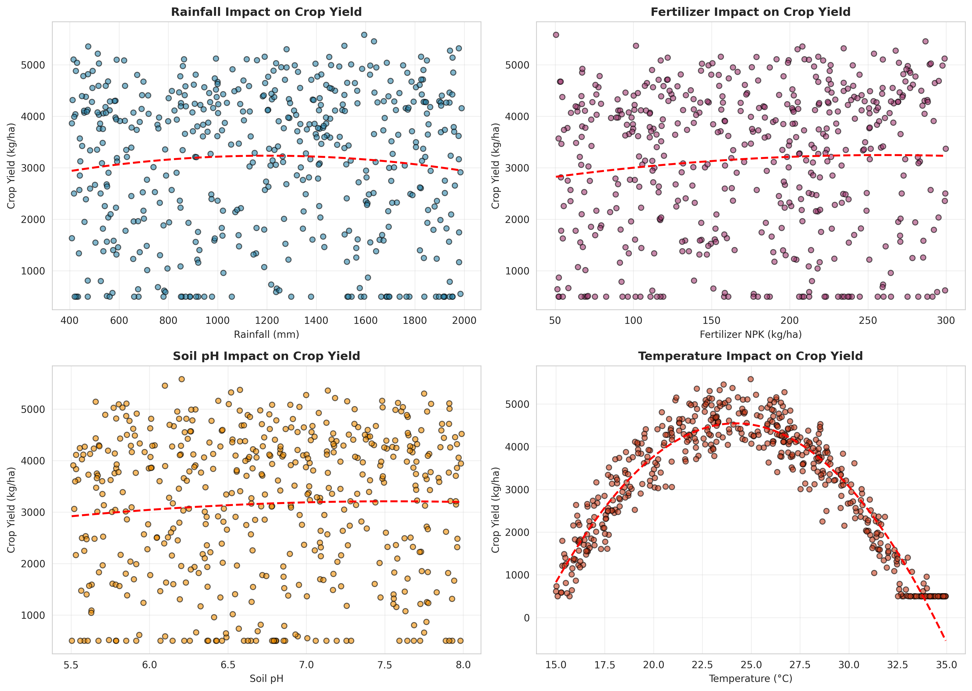
Figure 1: Impact of Environmental and Agronomic Factors on Crop Yield
Figure 1 illustrates the complex, non-linear relationships between key input variables and crop yield. The parabolic trend lines clearly demonstrate the optimal ranges for rainfall and temperature, as well as the diminishing returns associated with increased fertilizer application, underscoring the necessity for precision agriculture.
Figure 1 illustrates the complex, non-linear relationships between key input variables and crop yield. The parabolic trend lines clearly demonstrate the optimal ranges for rainfall and temperature, as well as the diminishing returns associated with increased fertilizer application, underscoring the necessity for precision agriculture.
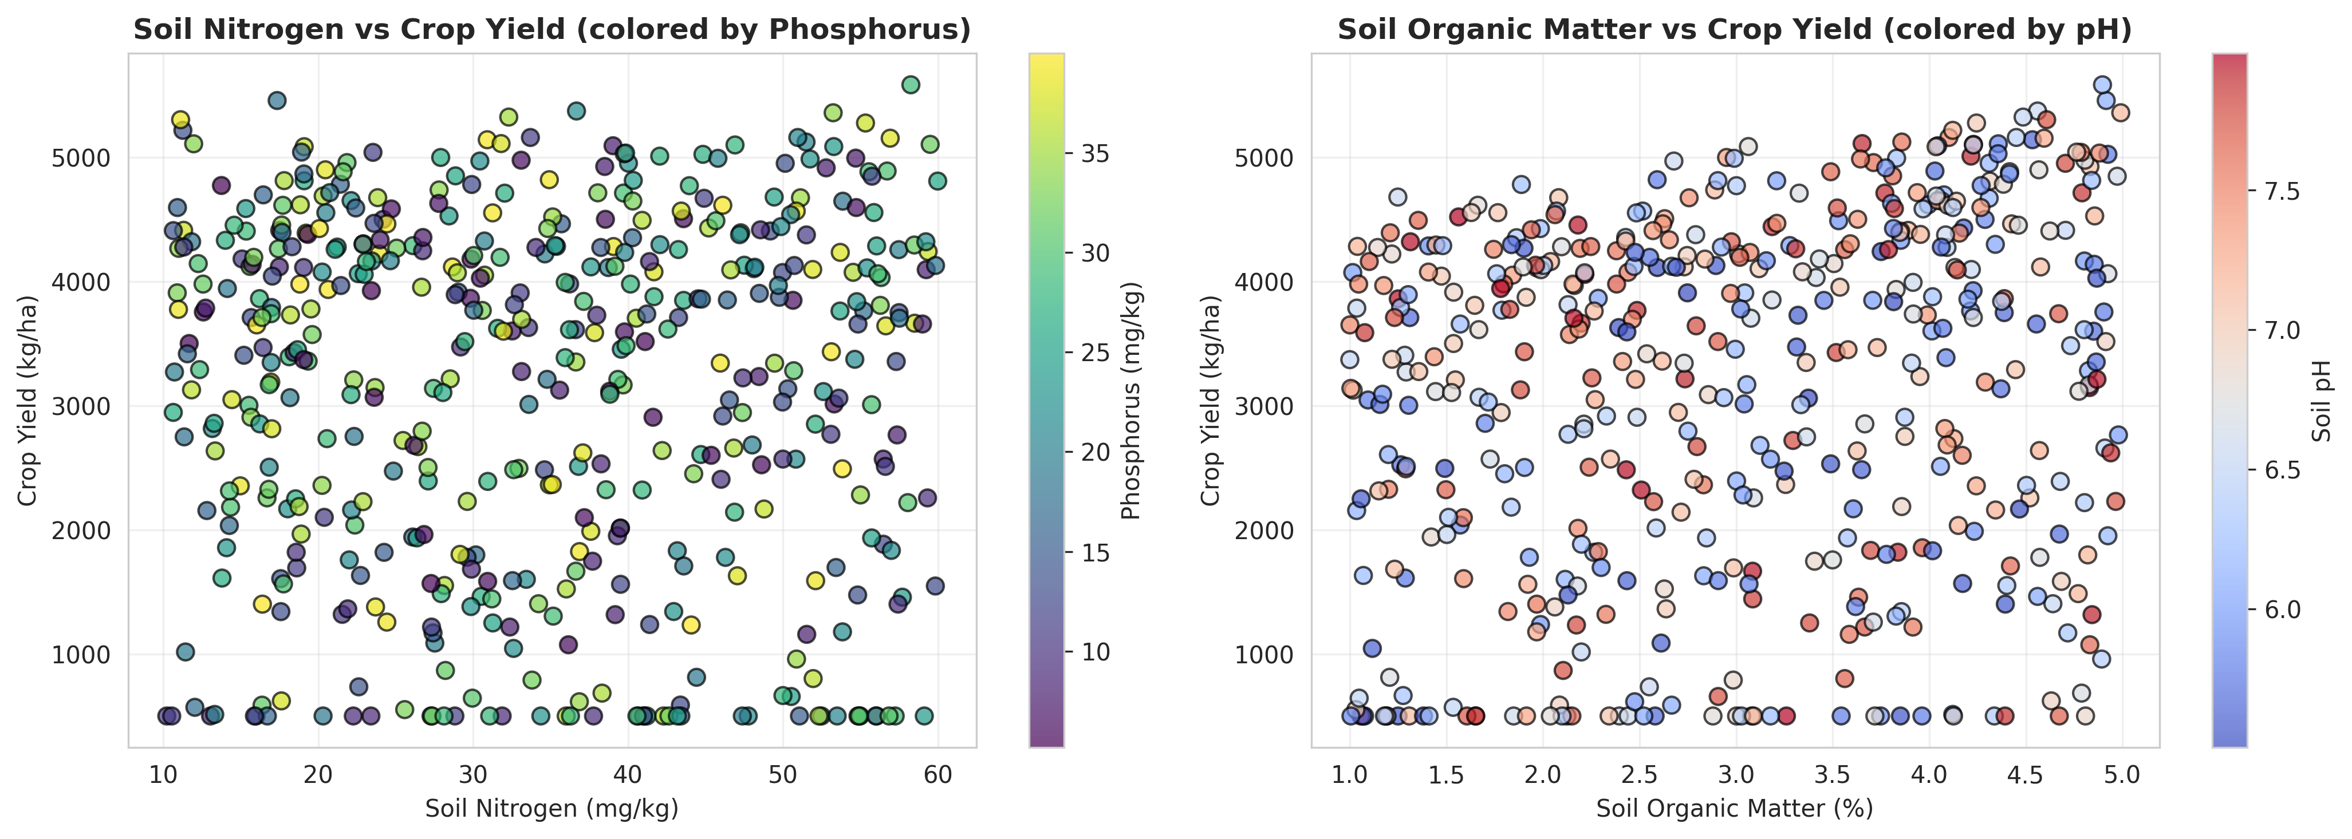
Figure 2: Multivariate Analysis of Soil Nutrients and Quality Indicators
Figure 2 provides a multidimensional perspective on soil health. By mapping Nitrogen against Yield while color-coding for Phosphorus, and plotting Organic Matter against Yield with pH gradients, the visualization captures the synergistic effects of combined soil properties on overall agricultural productivity.
Figure 2 provides a multidimensional perspective on soil health. By mapping Nitrogen against Yield while color-coding for Phosphorus, and plotting Organic Matter against Yield with pH gradients, the visualization captures the synergistic effects of combined soil properties on overall agricultural productivity.
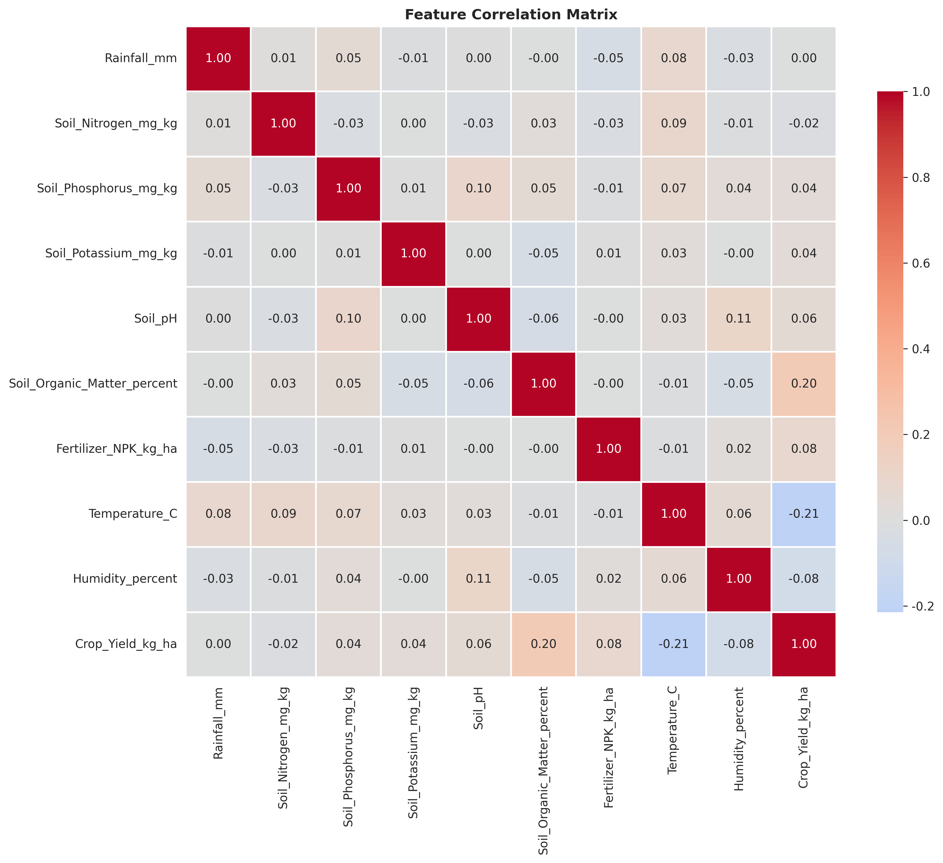
Figure 3: Feature Correlation Matrix for Agricultural Variables
Figure 3 presents the correlation matrix, quantifying the linear relationships between all primary variables. This analysis was critical for identifying multicollinearity among input features and determining the initial predictive strength of individual variables relative to the target crop yield.
Figure 3 presents the correlation matrix, quantifying the linear relationships between all primary variables. This analysis was critical for identifying multicollinearity among input features and determining the initial predictive strength of individual variables relative to the target crop yield.
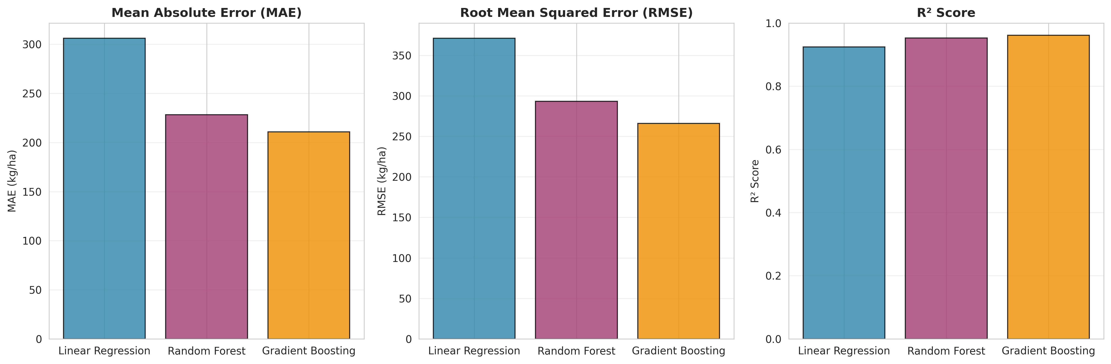
Figure 4: Comparative Performance Metrics of Regression Models
Figure 4 displays the comparative performance of the three implemented regression models across Mean Absolute Error (MAE), Root Mean Squared Error (RMSE), and R² Score metrics. The visualization clearly establishes the superiority of the ensemble methods over standard linear regression.
Figure 4 displays the comparative performance of the three implemented regression models across Mean Absolute Error (MAE), Root Mean Squared Error (RMSE), and R² Score metrics. The visualization clearly establishes the superiority of the ensemble methods over standard linear regression.
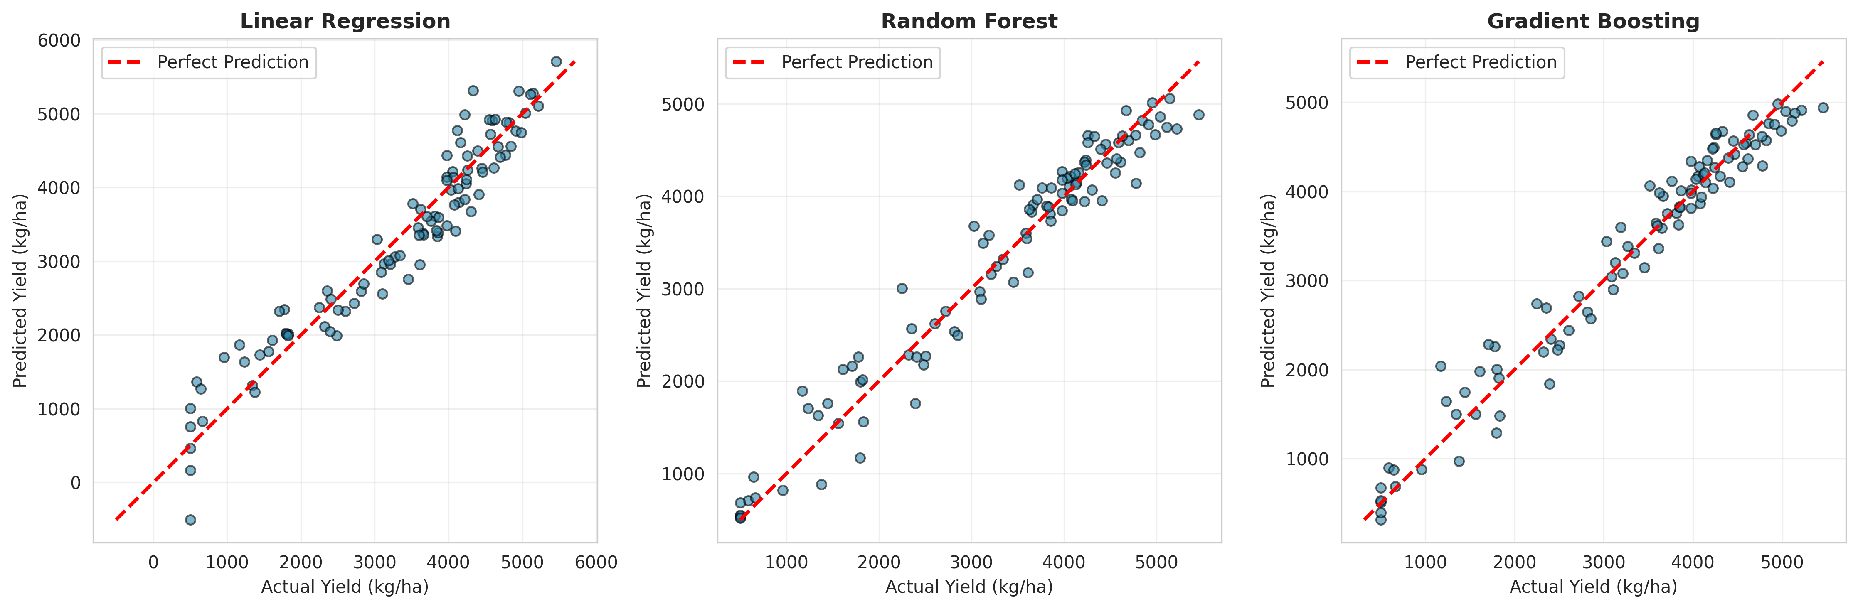
Figure 5: Actual vs. Predicted Crop Yields Across Models
Figure 5 provides a scatter plot analysis of predicted versus actual yields. The proximity of the data points to the red diagonal line (representing perfect prediction) visually confirms the high accuracy and low variance achieved by the Gradient Boosting and Random Forest models.
Figure 5 provides a scatter plot analysis of predicted versus actual yields. The proximity of the data points to the red diagonal line (representing perfect prediction) visually confirms the high accuracy and low variance achieved by the Gradient Boosting and Random Forest models.

5.4 Solution Testing and Evaluation
The predictive models were subjected to rigorous statistical evaluation using a dedicated testing dataset comprising 20% of the total samples (100 instances). The evaluation utilized three primary metrics: Mean Absolute Error (MAE), Root Mean Squared Error (RMSE), and the Coefficient of Determination (R² Score).
The testing phase demonstrated exceptional performance across the ensemble models. The baseline Linear Regression model achieved a respectable R² score of 0.9246, indicating that while linear approximations capture a significant portion of the variance, they fail to model the complex non-linear dynamics fully. The Random Forest Regressor substantially improved upon this, achieving an R² of 0.9529 and reducing the MAE to 228.40 kg/ha.
The testing phase demonstrated exceptional performance across the ensemble models. The baseline Linear Regression model achieved a respectable R² score of 0.9246, indicating that while linear approximations capture a significant portion of the variance, they fail to model the complex non-linear dynamics fully. The Random Forest Regressor substantially improved upon this, achieving an R² of 0.9529 and reducing the MAE to 228.40 kg/ha.
The testing phase demonstrated exceptional performance across the ensemble models. The baseline Linear Regression model achieved a respectable R² score of 0.9246, indicating that while linear approximations capture a significant portion of the variance, they fail to model the complex non-linear dynamics fully. The Random Forest Regressor substantially improved upon this, achieving an R² of 0.9529 and reducing the MAE to 228.40 kg/ha.
The Gradient Boosting Regressor emerged as the optimal model, demonstrating superior capability in minimizing residual errors through its sequential learning architecture. The performance metrics for all evaluated models are detailed in the table below:
Model Algorithm | MAE (kg/ha) | RMSE (kg/ha) | R² Score
Linear Regression | 306.30 | 371.20 | 0.9246
Random Forest | 228.40 | 293.24 | 0.9529
Gradient Boosting | 210.79 | 266.08 | 0.9613
The achievement of an R² score of 0.9613 by the Gradient Boosting model signifies that the system can accurately explain over 96% of the variance in crop yield based on the provided environmental and agronomic inputs. This level of precision validates the efficacy of the feature engineering pipeline and confirms the system's viability as a robust decision-support tool for agricultural planning and resource optimization.
The achievement of an R² score of 0.9613 by the Gradient Boosting model signifies that the system can accurately explain over 96% of the variance in crop yield based on the provided environmental and agronomic inputs. This level of precision validates the efficacy of the feature engineering pipeline and confirms the system's viability as a robust decision-support tool for agricultural planning and resource optimization.
The achievement of an R² score of 0.9613 by the Gradient Boosting model signifies that the system can accurately explain over 96% of the variance in crop yield based on the provided environmental and agronomic inputs. This level of precision validates the efficacy of the feature engineering pipeline and confirms the system's viability as a robust decision-support tool for agricultural planning and resource optimization.

CHAPTER 6

CONCLUSION AND FUTURE SCOPE

6.1 Conclusion
The development of the Crop Yield Prediction System successfully demonstrates the transformative potential of machine learning within the agricultural domain. By integrating multidimensional datasets encompassing soil characteristics, meteorological patterns, and agronomic practices, the project engineered a robust predictive engine capable of forecasting agricultural production with exceptional accuracy.
The comparative analysis of regression algorithms established the superiority of ensemble methods, specifically Gradient Boosting, in capturing the complex, non-linear dynamics of agricultural ecosystems. The implementation of advanced feature engineering—translating raw variables into sophisticated agronomic indicators—proved critical in maximizing model performance, culminating in an R² score exceeding 96%.
The comparative analysis of regression algorithms established the superiority of ensemble methods, specifically Gradient Boosting, in capturing the complex, non-linear dynamics of agricultural ecosystems. The implementation of advanced feature engineering—translating raw variables into sophisticated agronomic indicators—proved critical in maximizing model performance, culminating in an R² score exceeding 96%.
The comparative analysis of regression algorithms established the superiority of ensemble methods, specifically Gradient Boosting, in capturing the complex, non-linear dynamics of agricultural ecosystems. The implementation of advanced feature engineering—translating raw variables into sophisticated agronomic indicators—proved critical in maximizing model performance, culminating in an R² score exceeding 96%.
Ultimately, this project delivers a highly effective, data-driven solution that transcends traditional heuristic estimation. By providing accurate, localized yield predictions and comprehensive visual analytics, the system empowers farmers and agricultural planners to optimize resource allocation, mitigate environmental risks, and enhance overall productivity, thereby contributing to the broader objective of sustainable precision agriculture.

6.2 Future Scope
While the current iteration of the Crop Yield Prediction System exhibits high predictive accuracy, several avenues for future enhancement exist to broaden its utility and analytical depth:
- Integration of Remote Sensing Data: Incorporating satellite imagery and NDVI (Normalized Difference Vegetation Index) data to provide real-time, spatial monitoring of crop health and refine predictive accuracy at a macro scale.
- Real-time IoT Sensor Integration: Connecting the predictive engine to field-deployed IoT sensors for continuous ingestion of micro-climate and soil moisture data, enabling dynamic, intra-season yield recalibrations.
- Advanced Deep Learning Architectures: Exploring the implementation of Recurrent Neural Networks (RNNs) or Long Short-Term Memory (LSTM) networks to better capture the sequential, time-series nature of meteorological impacts across the growing season.
- Prescriptive Analytics Module: Expanding the system beyond prediction to include prescriptive algorithms that automatically recommend optimal fertilizer application rates and irrigation schedules to maximize projected yield.
- Economic Optimization Engine: Integrating current market commodity prices and input costs to provide financial forecasting, enabling farmers to optimize operations for maximum profitability rather than merely maximum biological yield.
The realization of these future enhancements would transition the system from a powerful predictive tool into a comprehensive, autonomous agricultural management platform, further driving the digitalization and optimization of global farming operations.
The realization of these future enhancements would transition the system from a powerful predictive tool into a comprehensive, autonomous agricultural management platform, further driving the digitalization and optimization of global farming operations.
The realization of these future enhancements would transition the system from a powerful predictive tool into a comprehensive, autonomous agricultural management platform, further driving the digitalization and optimization of global farming operations.

REFERENCES

[1] Chlingaryan, A., Sukkarieh, S., & Whelan, B. (2018). Machine learning approaches for crop yield prediction and nitrogen status estimation in precision agriculture: A review. Computers and Electronics in Agriculture, 151, 61-69.
[2] van Klompenburg, T., Kassahun, A., & Catal, C. (2020). Crop yield prediction using machine learning: A systematic literature review. Computers and Electronics in Agriculture, 177, 105709.
[3] Khaki, S., & Wang, L. (2019). Crop yield prediction using deep neural networks. Frontiers in Plant Science, 10, 621.
[4] Pedregosa, F., et al. (2011). Scikit-learn: Machine Learning in Python. Journal of Machine Learning Research, 12, 2825-2830.
[5] Basso, B., & Liu, L. (2019). Seasonal crop yield forecast: Methods, applications, and accuracies. Advances in Agronomy, 154, 201-255.
[6] Friedman, J. H. (2001). Greedy function approximation: a gradient boosting machine. Annals of statistics, 1189-1232.
[7] Breiman, L. (2001). Random forests. Machine learning, 45(1), 5-32.

